Staff Wellbeing Project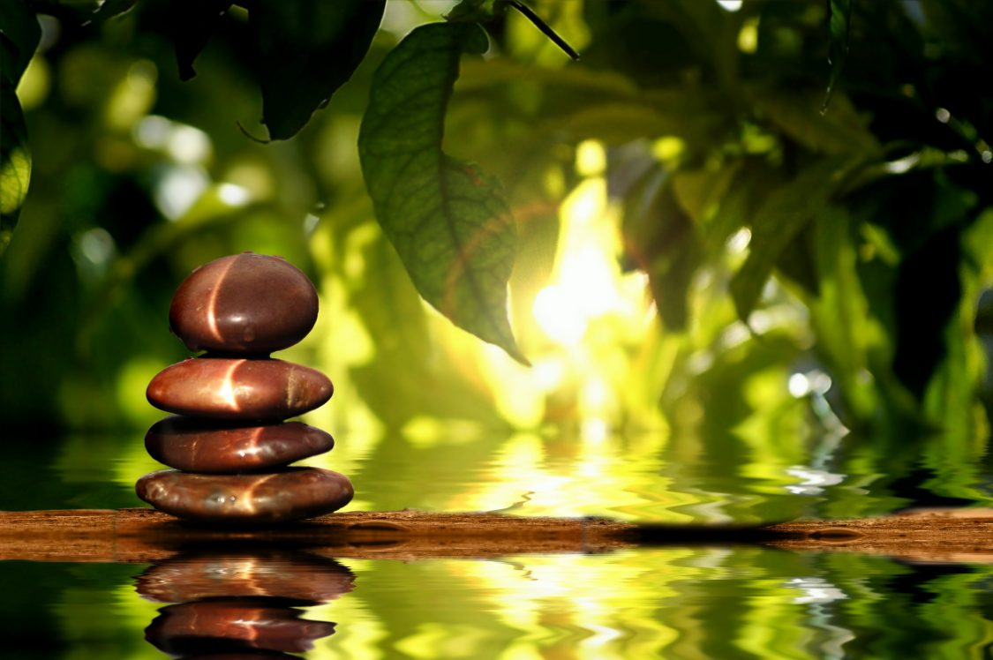
The Staff Wellbeing Project will deliver a rolling programme of activities to support staff wellbeing, the programme will run from November 2020 through to February 2021 and will include:
Mindfulness Taster sessions
Everyone is very welcome to join the weekly Mindfulness meditation taster sessions. Whether you practice regularly or you're curious about Mindfulness and it's your first time.

Mindfulness has been evidenced to help with stress and anxiety. The one hour session is experiential in nature and includes meditation practices

Sessions are drop in so please join as many of the sessions as you like as often as you like. It's a great way to try mindfulness for the first time, before committing to a course. We are also offering an 8 week Mindfulness for Stress course starting in January, see below.

Mindfulness for Stress - 8 week course
On this eight week Mindfulness for Stress course you will learn how to boost your happiness and well-being, find new sources of resilience, joy and calm in your life and how to cope with stress, anxiety, fear and depression. The course is run by experienced Mindfulness teacher Jim Ewing and delivered online using Zoom. You'll be given resources for practicing at home, including a handbook and access to a comprehensive set of guided meditations. The weekly themes of the course sessions are as follows:

- Mindfulness: Learning to choose
- Coming to our senses
- Working with thoughts
- Working with difficult experiences
- Noticing the good things
- Kindfulness
- The social dimension of Mindfulness
- The rest of your life

Tai Chi
Tai Chi is an outdoor exercise class suitable for all abilities. Come relax your body & mind in a friendly and tranquil atmosphere within the lovely Hidden Gardens.
Woodland Wellbeing Sessions
Come and relax in our woodland oasis in the city.
Sessions will be led by Lauren Lochrie. Lauren is a zoologist and nature conservationist with a wealth of experience in outdoor education and helping people connect with nature and the nature of themselves.
You will have the opportunity to take part in a range of nature based activities such as mindfulness, bushcraft, foraging, campfire cooking, herbal remedies, nature crafts and more.
Shiatsu
Shiatsu is a form of therapy which uses pressure points and gentle stretching to help you release tension where your body is holding on, and re-energise weak areas. Shiatsu touch is respectful and nourishing; it has been shown to increase physical and emotional feelings of wellbeing.
Hands-on sessions: One to one sessions with Glasgow School of Shiatsu's senior students under supervision will enable you to relax into a Shiatsu treatment which is tailored for your physical and emotional needs right now. Your ‘giver’ will apply pressure on relevant points and ‘meridians’ (as in Acupuncture) using sensitive touch with fingers and thumbs. They may include some stretches and rotations to help you release tension. The overall effect is relaxing and may also be energising. Sessions will strictly follow Governmental Covid-19 guidelines.
Group sessions online will allow you to learn a range of acupoints and simple practices to help you to help yourself, covering themes such as “self-help bodywork to deal with feeling anxious”, “relaxing stretches and acupoints to help unwind”, “self-massage to shift that headache”, “keeping positive in the dark winter months”. We will show you how to work on yourself using Shiatsu touch; how to access points for conditions like headache, menstrual issues, sleep problems, and digestive upset; how to energise yourself with simple body techniques you can use in everyday life. The class will be taken by a Teacher from the Glasgow School of Shiatsu, with senior students and recent graduates assisting to give individual back-up and instruction (in breakout rooms).
Further detail relating to each activity, in person venues and booking is available on the portal.
https://www.govanhillbaths.com/your-wellbeing-portal/ - password WellbeingPortalGH

