How to use this Discovery Map
Follow the numbers on the map to learn more about each area
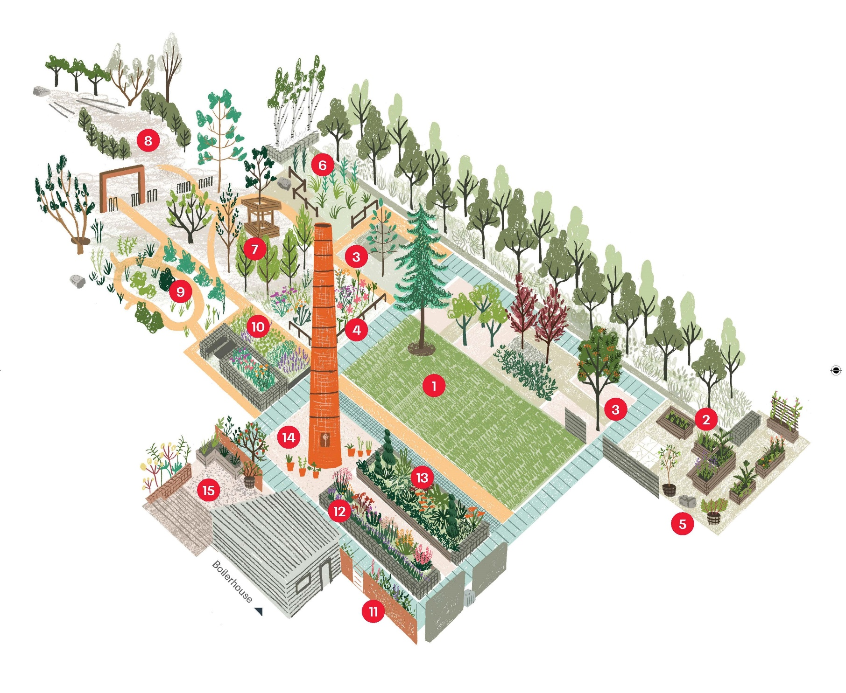

- Lawn & Gingko Tree
A Gingko Biloba tree is planted in the lawn. Now almost extinct in the wild, Gingko Biloba trees grew some 160 million years ago, including in Scotland.
- The Potager
Started in 2019, the ornamental kitchen garden is where you’ll find many kinds of vegetables and fruits.
- Native and Exotic Plant Collection
Trees and shrubs from around the world reflect local Scottish and Asian communities. Make a wish and offer it to the Wishing Trees (Trees near The Potager).
- Flowery Meadow
Plants here feed many different kinds of bees and pollinating insects for miles around.
- Inscribed Texts
Poems carved into 5 sandstone way markers that can be read in many ways. Can you find them all? Created by Gerry Loose.

- Shady Meadow & Himalayan Birch
See the white bark of the birch trees. Hear the rustling grasses that make seeds for the birds to eat during the colder months.
- The Xylotheque
A library of wooden books that shows different kinds of trees native to Scotland. Created by Alec Finlay.
- Woodland Glade
A quiet space surrounded by beech hedges and birch trees. Spot the old tram tracks. Be careful not to disturb the woodpiles, homes for insects and bees.
- Wildlife Area
Here you can find many of the creatures that make their home here, including the Bee & Butterfly Border where plants full of nectar feed bees and insects.
- Mint Border
There are hundreds of kinds of mint. Here you can find pineapple mint, ginger mint spearmint, apple mint, eau de cologne mint and catmint.

- White Wall Border
Admire the espalier fruit trees and herbaceous border. All loved by bees.
- Herb Border
A lovely smelling border of herbs that can be used for good health and good food.
- Scottish Ballet Border
Scottish Ballet sponsored this flower bed for their Ruby Anniversary, so the plants are different kinds of red, pink and purple.
- Chimney
Our plant kiosk is open in spring and summer. Flowering and edible plants available by donation.
- Medicinal Courtyard
A place of healing and relaxation.

